

Out of Hours Clinical Audit Toolkit

Gateway Number: 7790 March 2007
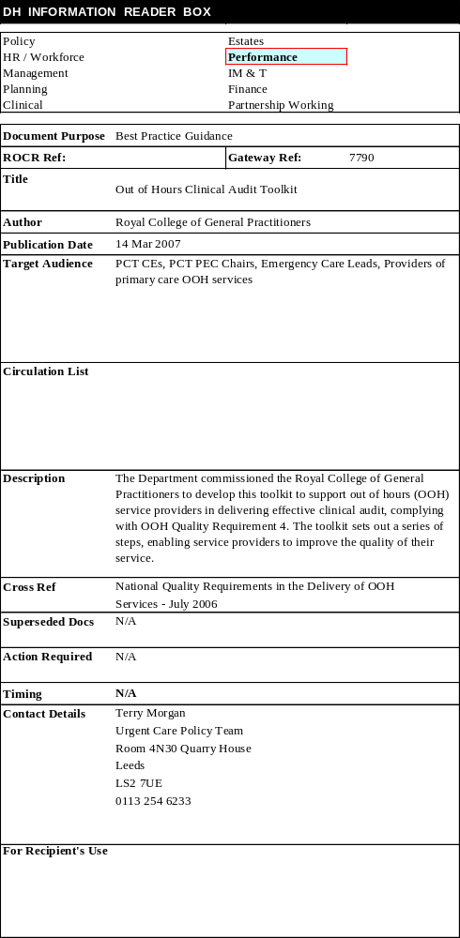

First printed March 2007
Copyright © 2007 Royal College of General Practitioners Quality Network

All rights reserved. No part of this publication may be reproduced, stored in a retrieval system or transmitted in any form or by any means, electronic, mechanical, photocopying, recording or otherwise, without the prior permission of the publishers.

This publication has been funded by the Department of Health and endorsed by the Royal College of General Practitioners.

Foreword

Under the National Quality Requirements, all providers of out-of-hours services have a responsibility regularly to audit the clinical quality of the service they provide. Some providers have found it difficult to develop practical and effective ways of meeting this requirement, and the Department of Health therefore commissioned the Royal College of GPs to develop a toolkit to enable providers to meet this Requirement more effectively. While commissioners and providers will of course make their own judgements about whether the approach set out here does in fact meet their needs, I hope that its publication will serve to refocus attention on what is a critical element in the safe and effective governance of any NHS service.

The toolkit builds on the secure foundations of existing best practice and has been trialled in several settings. It is the first in what its authors anticipate will be an iterative process. The more widely it is used, the more we will all learn about the most effective ways of conducting audits of this kind, and the better subsequent versions of the toolkit will be. It has been developed first and foremost to meet the needs of primary care providers of out-of-hours services, but as local health communities move towards a more integrated provision of urgent and emergency care, commissioners may want to extend its use to a wider variety of settings.

I would like to thank both the College and the team led by Dr Agnelo Fernandes that developed the toolkit. I am convinced that rigorous and effective clinical audit represents one of the most powerful tools at our disposal to improve the quality of the service we provide to patients, and I would urge all those who commission and provide out-of-hours services to give serious consideration to using this practical new tool.



Sir Liam Donaldson
Chief Medical Officer

Being ill in the middle of night can be a frightening experience for patients. Patients expect a responsive service that will establish a prompt and accurate diagnosis. The quality and safety of care out of hours is therefore all important. Providers need tools to monitor clinical outcomes to ensure compliance with the National Quality Requirements in the Delivery of Out of Hours Services published by the Department of Health in October 2004.

The Department of Health and the Royal College of General Practitioners are aware that standards must be met to ensure a high quality and safe service for the public. With this in mind this Out of Hours Audit Toolkit has been produced to monitor and improve out of hours services. This is an independent toolkit, and standards have been developed by experienced clinicians who have first hand knowledge of commissioning and providing out of hours services.

I would like to acknowledge the work of Dr Agnelo Fernandes, FRCGP, and his team – Drs, John Linney, David Lyell and Ravi Seyan FRCGP on this toolkit and would also like to thank Dr Mark Reynolds who provided background material to support the toolkit.


Professor Mayur Lakhani FRCGP
Chairman
Royal College of General Practitioners

Contents

Step 1: Identify the role of clinical audit within the organisation 7
Step 2: Define the Patient Pathway 9
Step 3: Define the Audit Criteria 11
Step 4: Practical Audit Tool 13
Step 5: Conducting the Audit 15
(a) Information gathering – IT systems, telephone calls, records 15
(b) Reporting and feedback - to individuals, the organisation and the PCT 16
(c) Acting on audit findings at individual and organisational levels including underperformance. 18
Step 6: Incorporate learning from other aspects of the service 19
Step 7: Repeat the audit cycle 21
References 22
Appendix 1: Resource allocation for conducting routine clinical audit 25
Appendix 2: Mapping the audit criteria to the “Consultation” 27
Appendix 3: Guidelines for Feedback 28
Appendix 4: Guidance on the use of the Out of Hours Audit Tool 29
(a) The key distinguishing features of this Out of Hours Audit Tool 29
(b) Using the Tool 29
(c) Call Handlers/Receptionists 30
(d) Clinicians (e.g. doctors, nurses, etc.) 31
(e) Rationale for using the Out of Hours Audit Tool 32
Appendix 5: Sample Quarterly Clinician Audit Report 37
Appendix 6: Sample Quarterly Call Handler Audit Report 38
Appendix 7: Sample Quarterly Out of Hours Organisation Audit Report 39

Introduction

Effective clinical audit constitutes the single most important method which any healthcare organisation can use to understand the quality of the service that is being provided. It provides a regular source of indispensable data both for the service provider and for commissioners. But far from being just a reporting tool, it provides a powerful mechanism for ongoing quality improvement, identifying weaknesses or shortcomings in organisational procedures or the practice of individual members of staff or the teams within which they work. Hardly surprising then that it is identified as one of key methods by which all organisations providing services to NHS patients deliver clinical and cost effectiveness.

But if all organisations have a duty to deliver effective clinical audit, those engaged in the delivery of out-of-hours (OOH) services face some particular challenges. OOH services are rarely delivered by full-time clinical or other staff (and some staff may only work on a very part-time basis) and providers will increasingly find themselves working collaboratively with other organisations in a local network of urgent care. The OOH patient pathway, therefore, may well involve more than one service provider, and effective clinical audit needs to take this into account. Both these realities are captured in OOH Quality Requirement 4 which sets the standard for clinical audit in the OOH environment.

This toolkit has been developed to support OOH providers in delivering effective clinical audit. It sets out a series of steps which will enable them to maximise the opportunities audit provides for continuous improvement in the quality of the service they provide:

- Step 1: Identify the role of clinical audit within the organisation
- Step 2: Define the Patient Pathway
- Step 3: Define the Audit Criteria
- Step 4: Define an Audit Tool
- Step 5: Conduct the Audit
- Step 6: Incorporate learning from other aspects of the service
- Step 7: Repeat the audit cycle

Step 1: Identify the role of clinical audit within the organisation

The critical importance of clinical audit must be clearly reflected within the management structure of the provider organisation, for it is only in this way that the obligation to plan, conduct, report, feedback and act upon the results of clinical audit will be properly realised. Those different elements are summarised in the following diagram:

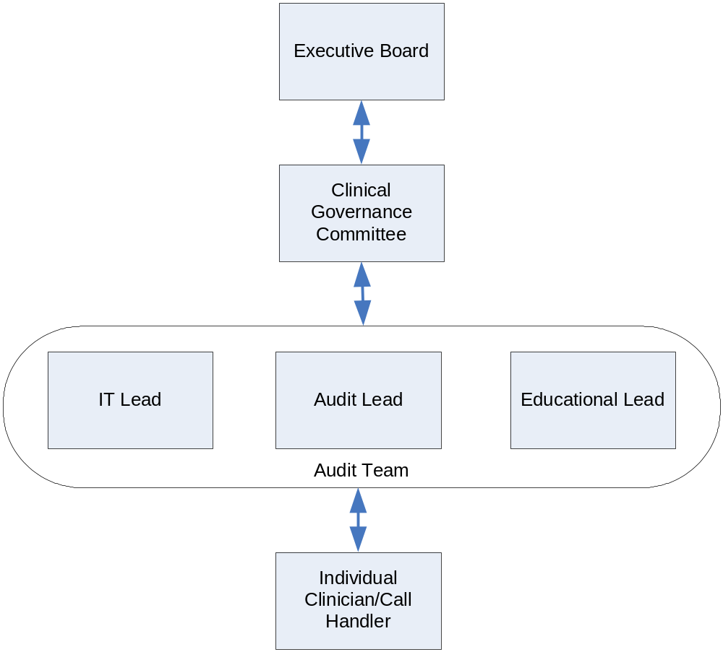

Fig 1: Management structure to deliver “effective” clinical audit

The essential aspect of any effective clinical audit programme will always be its outputs, both in terms of individual staff members and the organisation as a whole. Assessment, feedback, learning and implementation of change are all key elements in the delivery of real quality improvement, and these will only be delivered successfully where senior members of the organisation (at Board or Director level) are accountable for the specific functions set out in the diagram above.

How these roles and responsibilities will be delivered in practice will vary from organisation to organisation, and the approach set out in the diagram above might seem at first sight most suited to a medium or large provider with a well-developed management structure.

In reality, the different functions it describes are all critical in the successful delivery of clinical audit, and every service provider needs to find its own way of ensuring that they are all properly recognised within its own particular management structure. In a service that is provided by a PCT, for example, it may be that the clinical governance team can itself take responsibility for clinical audit. What matters is that the management responsible for each element in clinical audit is clear and unambiguous.

Clinical audit will only be effective where it is properly resourced and each provider will need to agree with its commissioner(s) precisely what these resources are and where they are to be found. While many providers will want to take sole responsibility for audit, and the costs associated with this will therefore be identified explicitly within the contract, others may wish to draw on resources that may exist elsewhere within the local health economy – within the PCT’s clinical governance team for example. Further discussion of these issues can be found in Appendix 1.

NOTES:

Step 2: Define the Patient Pathway

The fundamental precondition for effective clinical audit is an understanding of the OOH patient pathway within and between providers. The detail of the local pathway will vary, but it will always have a number of common features which are set out in the diagram below.

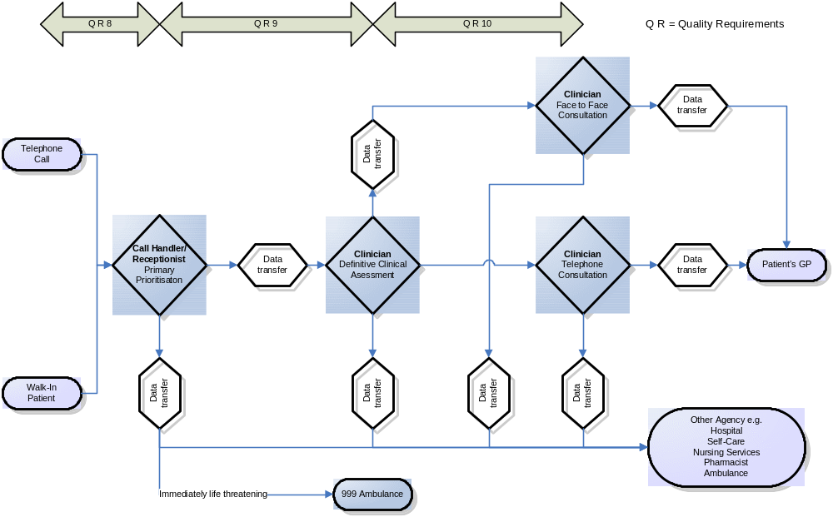

Fig 2: Generic OOH Pathway

This generic patient pathway can easily be mapped to local service provision, and in this way the key audit points related to initial access to the service and the different stages in the pathway can be easily identified. An OOH episode is triggered when a patient calls an OOH service or presents to a walk-in service and the patient pathway thereafter will usually consist of three main decision-making processes which are connected by the passing of information which could be electronic, on paper or by word of mouth.

- The initial decision-making process will usually be performed by a call handler or receptionist who will take initial information (including demographics) and carry out primary prioritisation (including the identification of an immediately life-threatening condition). They will then either pass the call to the next stage of the pathway or stream the call to another service.

- If the call remains within the OOH sphere, then the next decision-making process will be a definitive clinical assessment usually by a doctor or nurse although in some services this could be a pharmacist or an Emergency Care Practitioner (ECP).

- It is possible that the clinician will then pass immediately on to the next decision- making process in the form of:
  - A telephone consultation
  - A face to face consultation or
  - Passing the patient to another service (e.g. advised to attend A&E or to see their own GP).
The final decision-making process will therefore be either a telephone consultation or a face to face episode.

In order to audit the entire patient pathway, it is necessary to consider each of the points where decision-making takes place. The data transfer stages will be audited at an organisational level by Quality Requirements 8, 9 and 10. As these processes are unlikely to be affected by the behaviour of an individual, it will not usually be necessary to consider these for the purpose of clinical audit, which should focus attention instead on assessing the quality of decision-making within the pathway. Where an organisation is failing to meet Quality Requirements 8, 9 and 10, it may be necessary to examine the data transfer stages to ensure that they are not introducing unnecessary delay into the pathway.

NOTES:

Step 3: Define the Audit criteria

In developing a list of criteria against which performance can be audited, consideration has been given to a number of well-established principles and standards including:

- The GMC’s Good Medical Practice
- The Nursing & Midwifery Councils Code of professional conduct
- Standards for Better Health
- The RCGP’s criteria for ’Summative Assessment’ and MRCGP video consultation assessment.,,
- The Out of Hours Quality Requirements Error: Reference source not found
- Examples of current good practice Error: Reference source not found,

There are no evidence-based standards for the criteria chosen for contacts in the OOH period. The standard set for each criterion is the mean for the individual organisation and a scoring system can then be used to benchmark this mean score for each criterion as part of a formative approach to improving performance.

An audit tool requires a selection of core criteria against which different staff groups, organisations and modes of patient contact (from face-to-face interactions to those on the telephone) can all be assessed. While it would be possible to develop different criteria for each, there is value in having a single set of criteria which can be used for all staff groups and for all kinds of consultations. The application of those criteria will vary, but by using a single set of criteria it is possible to achieve a consistent interpretation when looking at the patient journey along the whole patient pathway, including those occasions where patients are passed from one provider to another.,

There may be circumstances in which local health communities want to modify or add to the twelve core criteria set out here - e.g. because of the use of paper-based or electronic protocols or algorithms. In particular, when staff are recruited from outside the UK, additional criteria that enable the assessment of their language skills, and their understanding of the local health economy and the local practice of medicine may also be necessary. But the principle of a consistent approach across a health community should not be lost. These core criteria are expanded in the generic audit tool and further explanations and guidance on its use is given in Appendix 4.

The audit criteria based on the ‘Consultation’

 | CRITERION | RATIONALE
1 | Elicits REASON for telephone call or visit | - Clearly identifies main reason for contact  - Identifies patient’s concerns [health beliefs]  - Accurate information e.g. demographics in CH’s
2 | Identifies EMERGENCY or serious situations | - Asks appropriate questions to exclude [or suggest] such situations  - Appropriate use of ILTC protocols
3 | Takes an appropriate HISTORY (or uses algorithm appropriately) | - Identifies relevant past Medical History / Drug History [including drug allergy]  - Elicits significant contextual information (e.g. social history)
4 | Carries out appropriate ASSESSMENT | - Face-to-face settings - appropriate examination carried out  - Clinician on telephone - targeted information gathering or algorithm use to aid decision making
5 | Draws appropriate CONCLUSIONS | - Clinician face-to-face/ telephone – makes appropriate diagnosis or differential / or identifies appropriate “symptom cluster” with algorithm use  - CH – makes appropriate prioritisation  - CH - streams call appropriately
6 | Displays EMPOWERING behaviour | - Acts on cues/beliefs  - Involves patient in decision-making  - Use of self-help advice [inc. PILs]
7 | Makes appropriate MANAGEMENT decisions following assessment | - Decisions are safe  - Decisions are appropriate (e.g. for face-to-face / A&E referral)
8 | Demonstrates appropriate PRESCRIBING | - Generics used [unless inappropriate]  - Formulary-based [where available]  - Follows evidence base or recognised good practice
9 | Displays adequate SAFETY- NETTING | - Gives clear and specific advice about when to call back  - Records advice given (worsening instructions)
10 | Develops RAPPORT | - Demonstrates good listening skills  - Communicates effectively [includes use of English]  - Demonstrates shared decision making
11 | Makes appropriate use of IT / Protocols / Algorithms | - Adequate data recording  - Face-to-face/phone/CH Use of IT tools where available/appropriate  - Clinician on telephone – appropriate use of support tools/algorithms
12 | Satisfies ACCESS criteria where appropriate [info available] | - Quality Requirements (See reference 2)

Step 4: Practical Audit Tool ,,,,

A generic audit tool is provided on the adjacent page for the review of individual call handlers and clinicians (doctors, nurses, etc.) in face to face settings or on the telephone. The detailed guidance notes provided in Appendix 4 will enable optimum use of this tool.

NOTES:
SCORING: Criterion fully met = 2 ; Criterion partially met = 1 ; Criterion not met = 0
Insert score (0 – 2) for each criterion for an individual either face to face or on the telephone.

 | CRITERION | Call Handler Receptionist | Clinician Telephone | Clinician face-to-face
1 | Elicits REASON for call/visit  - Clearly identifies main reason for contact  - Identifies patients concerns [health beliefs]  - Accurate information e.g. demographics in call handlers
2 | Identifies EMERGENCY or SERIOUS situations  - Asks appropriate questions to exclude [or suggest] such situations
3 | Appropriate HISTORY taking (or algorithm use)  - Identifies relevant PMH/DH [including drug allergy]  - Elicits significant contextual information (e.g. social history)
4 | Carries out appropriate ASSESSMENT  - Face-to-face settings: appropriate examination carried out  - Clinician on telephone - targeted information gathering or algorithm use to aid decision making
5 | Draws appropriate CONCLUSIONS  - Clinician face-to-face/ telephone – makes appropriate diagnosis or differential / or identifies appropriate “symptom cluster” with algorithm use  - CH – makes appropriate prioritisation  - CH - streams call appropriately
6 | Displays EMPOWERING behaviour  - Acts on cues / beliefs  - Involves patient in decision-making  - Use of self-help advice [inc. PILs]
7 | Makes appropriate MANAGEMENT decisions  - Decisions safe  - Decisions appropriate (e.g. face-to-face or A&E)
8 | Appropriate PRESCRIBING behaviour  - Generics used [unless inappropriate]  - Formulary-based [where available]  - Follows evidence base or recognised good practice
9 | Displays adequate SAFETY-NETTING  - Gives clear and specific advice about when to call back  - Records advice fully (worsening instructions)
10 | Develops RAPPORT  - Demonstrates good listening skills  - Communicates effectively [includes use of English]  - Demonstrates shared decision making
11 | Makes appropriate use of IT / Protocols / Algorithms  - Adequate data recording  - Face-to-face/phone/CH Use of IT tools where available/appropriate  - Clinician on telephone – appropriate use of support tools or algorithms
12 | Satisfies ACCESS criteria where appropriate [info available]

Step 5: Conducting the Audit

(a) Information gathering – IT systems, telephone calls, records

In order to review the performance of an individual working in an OOH service, it will be necessary to collate information from a number of sources. These could include:

Telephone system records
- access times

Computer system records

Productivity Data
- Average consultation times
- Average Triage times
- Calls triaged per hour / shift
- Face to face consultations per hour/shift

Outcome Data
Percentage of calls:
- where an immediate life threatening condition (ILTC) is identified
- streamed to another agency
- resulting in telephone advice
- resulting in home visit
- resulting in base visit
- referred to another agency (A&E, 999 ambulance, District Nurse, etc.)

Electronically held clinical records
- Consultation records
- Prescribing information
- Use of IT tools (PILs, Decision support etc)
- Outcome data

Voice Records
- Voice recordings of calls

Paper records
- Clinical records not held on computer

Feedback from patients

Complaints

Compliments

Feedback from colleagues

Significant Events

Serious Untoward Incidents (SUI’s)

Sampling arrangements must ensure that a random sample of the handled calls are systematically reviewed for each and every individual working within the organisation who contributes to clinical care. A minimum standard would be to ensure that at least 1% or 4 examples (whichever is the larger) of each individual’s calls/consultations are reviewed; should the results of this baseline audit identify any areas of concern about an individual’s performance, then a further 4% of that person’s calls/consultations should be sampled.

Organisations will develop their own regular audit cycle for their staff, but there is every reason to carry out early audits for new members of staff, where a larger sample (perhaps 2% or 8 calls /consultations) may be desirable. Equally, where doubts are raised about an individual’s performance (perhaps in a complaint, or in feedback from the patient’s own practice), then a prompt and more extensive audit may be necessary.

(b) Reporting and feedback - to individuals, the organisation and the PCT

Individual Reports
Individual clinical and non-clinical staff will only be able to benchmark their performance and monitor their progress if they receive regular individual audit reports (e.g. quarterly). Individual learning will be facilitated by audit reports that promote reflection on their practice as a way of influencing their behaviour for continuous quality improvement. , Samples of individual reports of a routine quarterly audit from both a call handler and a clinician are set out in Appendices 5 and 6

Individual Feedback
Providing feedback is very important for learning. Feedback is a process in which one individual makes comments on another person’s performance and its impact on others. Feedback should improve motivation as learners want to know how they are doing in any task so that they can improve and achieve their aspirations. As long as it is done constructively, feedback can also correct mistakes, providing there is reinforcement of what has been learnt and steps are taken to help learners reach their goals. Besides providing motivation to learners, effective feedback has the function of reinforcing appropriate knowledge or skills and correcting learner errors. Feedback offers insight into what did and did not go well. A variety of different techniques for communicating effective feedback have been developed in both medical and business education – see Pendleton (1984),Error: Reference source not found Ende (1983),Error: Reference source not found Hewson (1988) and Kurtz (1998) for examples.
Guidelines for giving feedback are provided in Appendix 3.

Organisational Reports
Providers are required to report regularly to commissioners on their compliance with the Quality Requirements. While many of these reports will be monthly, quarterly reporting makes much better sense for clinical audits, as it will allow more comprehensive coverage of staff, many of whom may only work part-time. These reports can be drawn from an amalgamation of individual staff audits. A sample organisational report is set out in Appendix 7.

Organisational Feedback and Learning
There is much to be gained by providing summaries of the reports of audit findings across the organisation to all staff groups to further facilitate learning and benchmark progress. Findings can be reported to the management board of the OOH organisation via the clinical governance group, and targeted educational activity can be organised for specific staff groups where further progress is required.

Feedback and Learning involving multiple providers
Where a local service configuration involves multiple providers in different segments of the OOH patient pathway, it has been difficult routinely to examine the quality of all the service contacts for an individual patient journey which includes both the decision-making and data transfer stages described previously. By using a generic clinical audit tool that is transferable across different providers, it becomes possible to review the quality of individual patient journeys through the urgent care system as a whole. So for example, the same 4 calls or episodes can be reviewed across all the relevant providers to allow consistent benchmarking against the audit criteria for good clinical care (including access).

NOTES:

(c) Acting on audit findings at individual and organisational levels including underperformance.

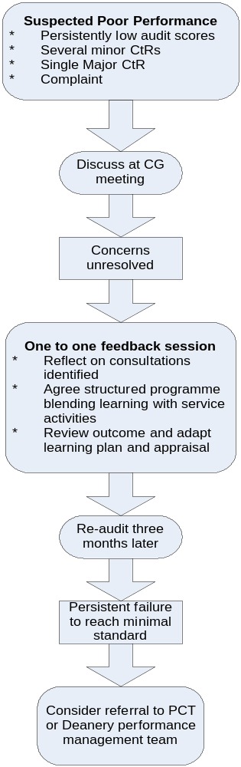
Individual action:
Individuals identified in the audit as having development needs can be selectively targeted for feedback and an action plan (involving reflection and planned review) may be helpful.
Organisational actions:
Developmental needs of individuals can be supported by the OOH organisation making resources available for appropriate feedback, developing a learning plan and providing a planned review to monitor progress.
Where there are specific areas to address in multiple individuals, group educational activity can be organised.
Where environmental or operational factors are identified as being responsible (in whole or in part) for criteria not being met, appropriate changes can be made e.g. better rostering, amenities, etc.

Persistent poor performer:
Such an individual may be identified in a number of ways – e.g. by numerous complaints, staff feedback or a failure to improve after educational input, as evidenced by a follow-up audit.
The organisation must then consider referral to the Performance Unit in the PCT or the Deanery. However, before taking this decision, there must be proper consideration of what other factors might have led to this poor performance – e.g. personal pressures (home, relationship, elderly parents, heath issues), or the situation at work (pressure of work, expectations, values, bullying) the attributes of the individual (extraversion, resilience, previous medical education, culture, values).
The individual who is being referred should be informed as to the reasons for the referral and what the expected outcome will be.

Step 6: Incorporate learning from other aspects of the service

In addition to the data that is assembled for clinical audit, every OOH service will also have access to other data that can provide invaluable additional information about the quality of the service that is being delivered. This data includes:
- The routine auditing of performance against the other Quality Requirements.
- Reports of Serious Untoward Incidents and Significant Events which have been investigated and which result in appropriate remedial action (where necessary).
- Feedback from those who use the service (patients and their carers) through questionnaires or other methods of understanding the patient experience of the service, including complaints and compliments.Error: Reference source not found
An effective organisation will want to ensure that all of this data directly supports its clinical governance. This can best be achieved by establishing rigorous policies and processes to record and collate this data, with at least quarterly meetings to review, learn and plan for any actions that may arise, including the identification of particular learning needs for individual members of staff. All staff, but particularly clinicians need to be encouraged to record significant events, with easily accessible recording facilities which are either electronic or paper based. There is also a need for routine mechanisms for collating and reporting on these entries, with dissemination of the learning (and any actions arising) to all staff in the organisation.

A multi-disciplinary and multi-agency governance group (that includes patients and commissioners) will act as an effective means of ensuring that there is organisational reflection across the entire service. Such a group could also facilitate performance review of the other Quality Requirements especially those relating to access to the service (e.g. QRs 8, 9 and 10).Error: Reference source not found

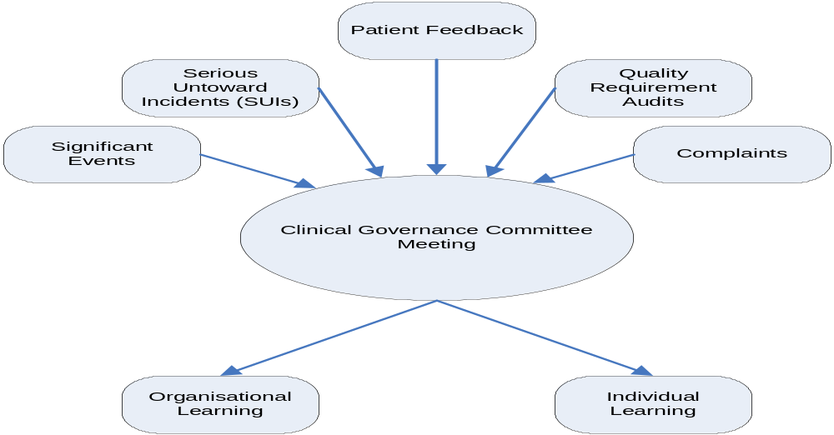

NOTES:

Step 7: Repeat the audit cycle

As the processes for routine clinical audit of OOH contacts become embedded, it will become apparent how audit can routinely inform both appraisal and performance review to drive the cycle of Continuous Professional Development (CPD)., As the diagram below illustrates, performance review may be triggered by the results of clinical audit itself or by other events such as a Serious Untoward Incident (SUI) or by a complaint from a patient. The end result is likely to be one-to-one feedback with the call handler or clinician, and an educational or action plan formulated. This will inform continuous medical or other professional education to address individual development needs.

Routine clinical audit has a key role in to play in CPD, both in the accepted cycle of annual appraisal and formulation of a Personal Development Plan (PDP) as well as the faster route of performance review.Error: Reference source not found,Error: Reference source not found Clinical audit conducted quarterly with feedback to OOH organisations and the individual creates the opportunity to inform PDPs more frequently. When used in this way, performance review can be seen as non-threatening and a means of benefiting both the individual and the organisation.

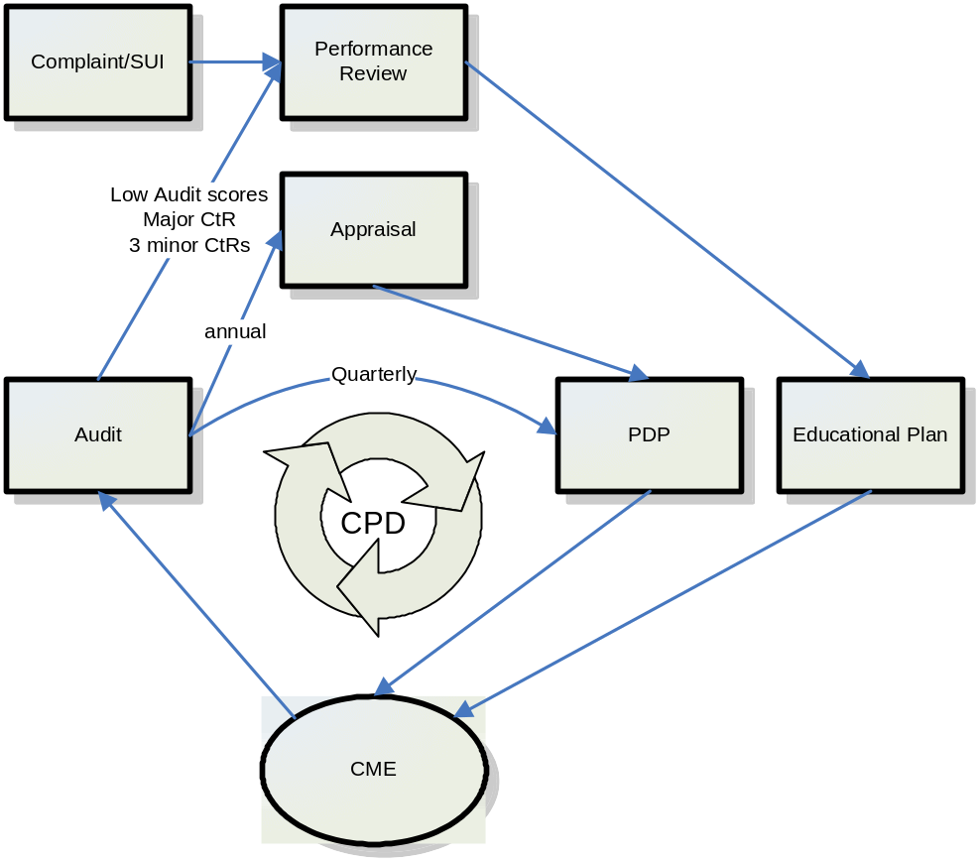

Fig 3: Routine clinical audit driving CPD

References

National Quality Requirements in the Delivery of Out-of-Hours Services, Department of Health, London, July 2006, Gateway No 6893
? Department of Health. Standards for Better Health. London: DH; 2004 (Criteria 5)
Department of Health. Out of Hours Quality Requirements. London: DH; 2006 (Requirement 4)
Department of Health. Out of Hours Quality Requirements. London: DH; 2006 Gateway No 6893.
General Medical Council. Good Medical Practice. London: GMC; 2006.
Nursing and Midwifery Council. The NMC Code of Professional Conduct: standards for conduct, performance and ethics. London: NMC; 2006.
Department of Health. Standards for Better Health. London: DH; 2004 Gateway No 2604
National Office for Summative Assessment. Assessment of Consulting Skills [Online]. London: NOSA. Available from: http://www.nosa.org.uk/information/video/introduction.htm [Accessed 05 February 2006].
Campion P, Foulkes J, Neighbour R, Tate P. Patient Centredness in the MRCGP Video Examination: analysis of large cohort. BMJ 2002; 325: 691-692.
Royal College of General Practitioners. Examination for Membership of the Royal College of General Practitioners (MRCGP): syllabus for examinations in 2006 (Section 7: Risk Management). London: RCGP. Available from: http://www.rcgp.org.uk/exams/examination_home/examination_information/syllabus_contents.aspx [Accessed 05 February 2006].
Examples from practice (On Call Care, Croydoc, Kernowdoc, Harmoni CPO, Local Care Direct, NHS Direct) and feedback from OOH conference 29 September 2006.
Hopton J, Hogg R, McKee I. Patients' Accounts of Calling the Doctor Out of Hours: qualitative study in one general practice. BMJ 1996; 313: 991-4.
Salisbury C. Postal Survey of Patients' Satisfaction with a General Practice Out of Hours Cooperative. BMJ 1997; 314: 1594-8.
Pendleton D. Schofield T. Tate P. Havelock P. The Consultation: an approach to learning and teaching. Oxford: OUP, 1984.
Pendleton D. Schofield T. Tate P. Havelock P. The New Consultation: developing doctor-patient communication. Oxford: OUP, 2003.
Neighbour R. Styles B. Haslam D. The Inner Consultation: how to develop an effective and intuitive consulting style. Abingdon: Radcliffe, 2004.
Tate P. The Doctor's Communication Handbook. Abingdon: Radcliffe, 2004.
Arborelius E, Bremberg S. What Can Doctors Do to Achieve a Successful Consultation? Videotaped Interviews Analysed by the 'Consultation Map' Method. Fam Pract 1992; 9: 61-6.
West M. How Can Good Performance Among Doctors be Maintained? BMJ 2002; 325: 669-670.
Rethans J, Westin S, Hays R. Methods for Quality Assessment in General Practice. Fam Pract 1996; 13: 468-476.
Peiperl MA. Getting 360 Degrees Feedback Right. Harv Bus Rev 2001; 79: 142-7.
Ende J. Feedback in Clinical Medical Education. JAMA 1983; 205: 777-81.
Hewson MG, Little ML. Giving Feedback in Medical Education: verification of recommended techniques. J Gen Intern Med 1988; 13: 111-6.
Kurtz SM. Silverman J. Draper J. Teaching and Learning Communication Skills in Medicine. Abingdon: Radcliffe, 1998.
Thompson K. Parahoo K. Farrell B. An Evaluation of GP Out-of-Hours Service: expectations of care. J Eval Clin Pract 2004; 10: 467-474.
Taylor CM, Wall DW, Taylor CL. Appraisal of Doctors: problems with terminology and a philosophical tension. Med Educ 2002; 6: 667-71.
Bloom BS. Effects of Continuing Medical Education on Improving Physician Clinical Care and Patient Health: a review of systematic reviews. Int J Technol Assess Health Care 2005; 21: 380-5.
?? Goodyear-Smith F, Whitehorn M, McCormick R. General Practitioners' Perceptions of Continuing Medical Education's Role in Changing Behaviour. Educ Health 2003; 16: 328-38. Useful Websites Membership of the Royal College of General Practitioners examination syllabus – Risk management (7) http://www.rcgp.org.uk/exams/examination_home/examination_information/syllabus_contents/risk_management.aspx Good Medical Practice ‘Protecting patients guiding doctors’, General Medical Council, UK, May 2001 http://www.gmc-uk.org/ The NMC code of professional conduct: standards for conduct, performance and ethics, The Nursing & Midwifery Council, UK, July 2004 http://www.nmc-uk.org Summative Assessment’ and MRCGP video consultation assessment/The National Office for Summative Assessment, London http://www.nosa.org.uk Glossary of terms CH Call Handler CME Continuing Medical Education CtR Call to Reflect upon DH Drug History GP General Medical Practitioner ILTC Immediately Life Threatening Condition OOH Out of Hours PCT Primary Care Trust PDP Personal Development Plan PILs Patient Information Leaflets PMH Past Medical History QR Quality Requirement (from national OOH Quality Requirements) SUI Serious Untoward Incident Appendix 1 Resource allocation for conducting routine clinical audit The ability of providers to conduct routine clinical audit has been limited by a number of factors, including the immaturity of IT systems, the lack of a consistent audit tool and concerns about costs. Routine audit in OOH services has largely concentrated on areas of organisational performance rather than on the quality of individual patient contact. The exception being in response to a patient complaint. However, some providers recognised the critical role of routine clinical audit in improving service quality and have included the associated costs within their contracts. In accurately identifying those costs, a range of options need to be considered to ensure that clinical audit is adequately resourced. These might include: - The pooling of resources between providers to perform the audit function more cost effectively. - Funding from commissioners extra-contractually where possible. - The use of other existing PCT resources (e.g. within the clinical governance team) especially where the provider is a PCT. - Absorbing the costs in year with inclusion in contract negotiations when these next come up for renewal. Given that OOH service provision is a contestable arena, most viable providers can solve any resource gap by working closely with their PCT(s). The cost of routine clinical audit will vary between providers and services and where it is embedded with other quality measures, the overlap in functions can make it very difficult to estimate its real cost. However, where a new routine clinical audit is to be implemented the following factors need to be considered: - The need for a senior clinician to act as an accountable lead for clinical audit, and educational support for feedback and to address outliers in clinical performance - The need for an audit team, the size of which will be dependant on the size of the provider and the numbers of personnel whose patient contacts are routinely reviewed. - Time for the assessment of a minimum of 1% or 4 examples of each individual’s calls/consultations per quarter (for both call handlers and clinicians) as a recurring routine audit sample. A further 4 calls of individuals identified as having ‘calls for concern’, and 2% or 8 calls/consultations for new staff members early in their employment; with more extensive call reviews in response to adverse patient or practice feedback or complaints. - Using a simple but effective audit tool, an average assessor (doctor, nurse or other professional) can expect to review up to 10 Call Handler calls (including documentation) per hour and up to 6 clinician calls/consultations per hour (including documentation). - Administrative support to retrieve audio recordings and electronic documentation. Paper based systems will always be more labour and resource intensive. - IT support to randomly identify calls/consultations, maintain databases of individual performance and for the generation of both individual and organisational reports. The OOH software supplier needs to be encouraged to develop the necessary standard reports. Appendix 2 Mapping the audit criteria to the “Consultation” Components of the ‘Consultation’ Audit Tool Criteria1. Identifies reason for presentationElicits reason for presentation1. ReasonResponds to cues6. EmpoweringElicits relevant info to place presentation on context3. HistoryExplores and uses health understanding6. Empoweringobtains sufficient information to assess whether immediate action indicated2. Emergency2. Defines problemObtains additional relevant information including PMH and ‘red flags’2. Serious 3. HistoryObtains DH [including allergies]3. HistoryMakes an appropriate assessment of physical and mental state4. AssessmentShows evidence of hypothesis generation5. ConclusionsArrives at an appropriate working diagnosis or disposition5. Conclusions3. Shares problemShares findings/thoughts on diagnosis or disposition6. EmpoweringTailors explanation to patients beliefs and understanding10. RapportDemonstrates appropriate use of language10. RapportSeeks to confirm patient understanding and acceptance6. Empowering4. Manages problemDiscusses proposed management (and options where appropriate) with patient6. EmpoweringDefines mutually agreed management plan7. ManagementManagement plan is appropriate to working diagnosis and reflects good practice wherever possible7. ManagementMakes appropriate use of resources (referral, other professionals etc.)7. ManagementDemonstrates appropriate prescribing behaviour8. Prescribing5.Ends consultationDemonstrates appropriate use of time12. AccessClearly defines symptoms/signs/reasons to trigger further consultation (safety netting)9. Safety nettingConfirms patients understanding and acceptance of safety netting6. EmpoweringAccurately records all relevant data11. IT Appendix 3 Guidelines for Feedback * Setting the Scene - Create an appropriate environment - Clarify your ground rules with the health care professional – which part of the results of the call audit i.e. from the 12 criteria or other sources of information (complaint, patient feedback or SUI) you will concentrate on, and when you will interrupt. - Agree a teaching focus - Make notes of specific points Giving Feedback – DO’S - Establish the health care professional’s agenda - Get them to start with what went well in the OOH consultation – the positive - Teacher starts positive if prompting is needed – however difficult it may seem - Comment on specific aspects of the consultation – i.e. in history taking - Active listening (eye contact, stance etc.) - Use of silence - Clarifying - Responding to cues (verbal, non-verbal, psychosocial) - Summarising - Empathising - Move to areas ’to be improved’ (avoid the term ’negative’!) – follow the health care professional’s agenda first - Ask individual to comment, but remind them there is ’No criticism without recommendation’ - Offer own observations & constructive criticisms - Be specific - Always offer alternatives - Begin with: “…I wonder if you had tried…” “…perhaps you could have…” “…sometimes I find…helpful…” - Distinguish between the intention and the effect of a comment or behaviour - Distinguish between the person and the performance - (“What you said sounded judgmental” – rather than “You are judgmental”) - Discuss clinical decision making - Be prepared to discuss ethical and attitudinal issues if they arise Giving Feedback – DON’TS - Don’t forget the receiver’s emotional response - Don’t criticise without recommending - Don’t comment on personal attributes (that can’t be changed) - Don’t generalize *Goodyear-Smith F, Whitehorn M, McCormick R. General Practitioners' Perceptions of Continuing Medical Education's Role in Changing Behaviour. Educ Health 2003; 16: 328-38. Appendix 4 Guidance on the use of the Out of Hours Audit Tool This audit tool is intended to be simple and intuitive. It is designed to capture the main components of patient contacts with OOH services while providing a framework to examine and develop the quality of calls and consultations using established educational approaches for good practice.? Many OOH organisations are already using similar tools based on the same essential elements for their audit of the work of clinicians, but use a separate approach for call handlers. The auditing of call handlers and clinicians is different, and this is illustrated most obviously by the fact that while a senior and experienced clinician will be able to review all calls and consultations (regardless of the member of staff involved), in most circumstances an equally experienced supervisor would probably only feel confident in reviewing the calls of call handlers or receptionists. However, there are real benefits in using a single audit tool across all staff groups, and as experience grows, the benefits of using multidisciplinary audit teams who work across professional boundaries will become clearer. (a) The key distinguishing features of this Out of Hours Audit Tool - The same set of minimum criteria are used for both call handlers and clinicians (e.g. doctors, nurses, etc) although they may interpreted differently. - The same set of minimum criteria are used for different settings e.g. on the telephone or face-to-face (e.g. a call handler or clinician on the telephone and a clinician face-to-face). - The same set of minimum criteria are used along the patient pathway involving the three main decision points – (a) prioritisation/streaming, (b) definitive clinical assessment/triage by a clinician, (c) clinical consultation on the telephone or face-to-face - The same set of minimum criteria can be used by different providers involved in telephone or face-to-face contacts. - The success measure for each criterion is outcome rather than process based as the marking schedule shows. (b) Using the Tool The aim of the marking schedule (with scores 0, 1 or 2) is to help individuals benchmark their performance against the criteria in relation to the organisation’s mean score for any individual criterion. This is both to aid reflection and to enable an individual to monitor their progress. It is also one of the mechanisms that OOH organisations can use to monitor different elements of the quality of contact it has with patients. Providing a framework based on the minimum criteria of good practice will help identify outliers with development needs, and enable the proper planning of measures to address those needs. Each of the twelve criteria includes subsidiary components which are prompts for the essential elements relating to that criterion. The marking schedule illustrates how the subsidiary components can be used to determine if a particular criterion is being met – fully, partially or not at all. It is particularly important to emphasise that these prompts are not intended to promote a ‘tick box’ approach to the audit. Rather, they are included to provide a rationale for determining if a particular criterion is in fact being met. Thinking through the extent of compliance with these different subsidiary components will make it much easier to explain the basis for a ‘Call to Reflect’ (for an explanation of this term, see Marking Schedule Section). (c) Call Handlers/Receptionists Both the audio recording of telephone contacts, and the documentation generated by the call, will be used for the audit. The audit could either be conducted live, with the reviewer sitting with the call handler as they take calls or, retrospectively, with access to the audio recording and supporting documentation (electronic or paper based). Apart from criterion 8 which relates to prescribing, all the other criteria are relevant to call handlers. A call handler can be expected to: - Note the reason (1) for a call. - Identify a life threatening condition or emergency (2) using appropriate protocols. - Take initial details of a patient’s history (3) (e.g. ‘Breathless’, ’known heart patient’, lives alone, etc.). - Take details of the patient’s condition in terms of a simple assessment (4) (e.g. not well and bed bound, house key with neighbour). - Working from appropriate protocols (electronic or paper-based), draw appropriate conclusions (5) in terms of prioritisation times to definitive clinical assessment (20 minutes or 60 minutes) or stream the call - e.g. to a district nurse. - Empowering behaviour (6) may include: calming the patient down; giving simple first aid advice until the clinician or ambulance crew make contact; providing reassurance that the patient is not being a bother and that clinical advice is needed. - Safe or appropriate overall management decisions (7) in terms of prioritisation times chosen, live call transfer to a clinician, or streaming to the appropriate professional or service. - Advice on calling back or calling an ambulance if the condition worsens before definitive clinical assessment can begin is an essential part of safety netting (9). - Listening to the recording of the telephone contact quickly establishes whether rapport (10) is established with the patient - e.g. introductions, listening, the patient understanding the call handler’s language, etc. - In organisations where the call handler uses decision support software or algorithms (for prioritisation or streaming) the appropriate use of these IT tools/protocols/ algorithms (11) can be established using both the audio cues and the electronic records. In organisations that do not use such decision-support systems, the appropriate use of OOH software and paper based protocols can be reviewed. Most providers are using paperless systems which greatly facilitate the audit processes. Those providers still using largely paper-based systems need to be encouraged to migrate to more effective electronic recording systems. - The main access criteria (12) relating to call handlers are Quality Requirements 8 and 9 - relating to access to the service (abandonment rate) and the identification of a life threatening call respectively. Although the access to the service may be an organisational issue, individual behaviour can affect compliance. Listening to the audio recording of a call can reveal how long the patient was held once connected Also, listening to the ongoing scripted message or how long there was before a ringing tone provides further evidence of the time call answering was delayed. However the latter features will depend on individual providers’ telephone systems. (d) Clinicians (e.g. doctors, nurses, etc.) The audit tool is designed around the model consultation. The criteria in the audit tool relate to the consultation (Appendix 2) which corresponds to the decision points of definitive clinical assessment or triage, as well as clinical consultations face-to-face or on the telephone. Prescribing will be primarily limited to the face-to-face setting. For providers whose clinicians use decision-support systems or algorithms (on the telephone or face-to-face) without the traditional clinical consultation markers outlined in (Appendix 2), the core criteria can still be applied given that the audit tool is outcome-based. The aim is that compliance with each criterion is inferred from: the algorithm that was used, the questioning within the algorithm, and the outcome or end point both in terms of clinical rationale and disposition. A ‘diagnosis’ is not an end point in some systems, even though the symptom cluster may point to one, hence the term ’draws appropriate conclusions’ is used in criterion 5. Compliance with this criterion is demonstrated if the appropriate algorithms are used, provided that each stage within the algorithmic structure includes an appropriate rationale. All other criteria should map across easily to clinicians, whether or not they use decision-support software. It is clear that ten of the twelve criteria that have been selected have been in general use with many OOH providers for some time, albeit in different combinations and applied in different ways. It is also clear that there is now a much wider understanding of what full compliance with Quality Requirement 4 means. However two of the criteria (displays ‘empowering behaviour’ and ‘develops rapport’) may be less well known. When mapping the audit criteria to the consultation (Appendix 2) it becomes apparent that empowering behaviour is a key part of a good consultation, and it can be inferred from the subsidiary components in that criterion. While it is much easier to assess compliance with the criterion ’develops rapport’ in telephone-based consultations or observed face-to-face contacts, it may be possible to infer rapport from the extent to which the clinical notes demonstrate shared decision-making. The audit tool sets out the minimum core criteria which will enable providers to deliver consistent and effective clinical audit, but some providers may wish to add further subsidiary components depending on the particular ways in which urgent care is delivered in their local health community. (e) Rationale for using the Out of Hours Audit Tool: CRITERIONNot met ( 0 )Partially met ( 1 )Fully met ( 2 )1 Elicits REASON for call/contact - Clearly identifies main reason for contact - Identifies patients concerns [health beliefs] Accurate information e.g. demographics in call handlersClinician does not identify reasons or concerns accurately CH does not record reason or concern accuratelyClinician identifies reason CH accurately records details or problem Clinician accurately identifies all CH accurate both details & problem 2Identifies EMERGENCY or SERIOUS situations Asks appropriate questions to exclude [or suggest] such situationsNo: Does not exclude an emergencyQuestioning adequately excludesExcludes emergency well3Appropriate HISTORY taking (or algorithm use) - Identifies relevant PMH/DH [including drug allergy] Elicits significant contextual information (e.g. social history)Does not elicit relevant historyElicits basic history without contextual informationElicits full history including contextual4Carries out appropriate ASSESSMENT - Face-to-face settings - appropriate examination carried out Clinician on telephone - targeted information gathering or algorithm use to aid decision makingNo appropriate examination nor information gathering nor algorithm useAdequate examination, information gathering or algorithm useGood - appropriate actions5Draws appropriate CONCLUSIONS - Clinician face-to-face/ telephone – makes appropriate diagnosis or differential / or identifies appropriate “symptom cluster” with algorithm use - CH – makes appropriate prioritisation CH - streams call appropriatelyNo: does not draw appropriate conclusions in respective setting Adequately draws appropriate conclusions in respective settingDraws appropriate conclusions well in respective setting6Displays EMPOWERING behaviour - Acts on cues / beliefs - Involves patient in decision-making Use of self-help advice [inc. PILs]No: does not act on cues / beliefs nor involve patient nor use self helpAt least one of the featuresAt least 2 or 3 of the features7Makes appropriate MANAGEMENT decisions - Decisions are safe Decisions appropriate (e.g. face-to-face or A&E)Decisions neither safe nor appropriateDecisions either safe or appropriateDecisions safe and appropriate8Appropriate PRESCRIBING behaviour - Generics used [unless inappropriate] - Formulary-based [where available] Follows evidence base or recognised good practicePrescribing unsafe or involves none of the featuresAppropriate with either one or two of the featuresAll 3 features are present9Displays adequate SAFETY-NETTING - Gives clear and specific advice about when to call back Records advice fully (worsening instructions)Neither clear call back advice nor full recording of worsening adviceEither of the 2 features presentBoth of the 2 features present10Develops RAPPORT - Demonstrates good listening skills - Communicates effectively [with use of English] Demonstrates shared decision makingNeither listens nor is understandable nor shares decisions Either one or two of these features are presentAll three of these features are present11Makes appropriate use of IT / Protocols / Algorithms - Adequate data recording - Face-to-face/phone/CH Use of IT tools where available/appropriate Clinician on telephone – appropriate use of support tools or algorithmsPoor documentation, the use of IT system, use of decision support tools or of algorithmsAdequate records, use of IT, decision support tools or algorithmsGood records, use of IT, & decision support tools and aids12Satisfies ACCESS criteria where appropriate [info available] None of QR access criteria satisfied1 or 2 of the QR access criteria satisfiedAll of the QR access satisfied Although it is possible to score each criterion using 2 [fully or largely met], 1 [partially met] and 0 [not met], the table above shows that some standards are more important than others. For certain groups a zero in some criteria for may be considered enough to designate it a Call to Reflect upon (CtR). Marking Schedule The marking schedule has been devised for simplicity and ease of use and there are three possible scores for each of the criteria: - 0 – criterion not met - 1 – criterion partly met [or acceptable – minimally safe and can be improved] - 2 – criterion largely or fully met In addition to the composite score it is recommended that any elements of concern should lead the assessor to designate it a Call to Reflect upon (CtR). In most cases these will be minor but nevertheless worthy of reflection by the individual, and will aid learning for all (as in the sharing of information about significant events). A small number will be considered major, requiring immediate intervention and/or education (e.g. incorrect prioritisation or streaming by a call handler, ignoring an algorithm where these are used, failure to recognise a serious condition in face-to-face contact). In terms of the most effective targeting of additional educational support, it would make sense to focus on those with low average scores (e.g. the bottom 10%) and/or those with several CtRs (3 per annum or if more than 10% of an individual’s calls/consultations are identified as CtRs if many calls/consultations reviewed). This will lead in turn to a proactive approach, providing the learning from CtRs is shared with appropriate groups of staff clinicians or call handlers. Scores from the clinical audit involving patient contacts on the telephone or face-to-face can be collated for feedback to individuals and summarised in an organisational report at least quarterly, either in a paper-based or electronic form. Summary - The tool aims to cover the core aspects of all OOH contacts. - The aim of a generic set of criteria and a generic tool for a variety of staff (including clinical and non-clinical staff) is to promote consistency in quality and standards. - Generic terms have been used to achieve consistency - e.g. examination covered by ‘assessment’ and diagnosis and disposition by ’conclusions’. - The core criteria are considered essential and have been defined in such a way that they should encompass a wide range of variance. If, however, an individual organisation wishes to add additional criteria to reflect their particular model or pathway or processes, then they are of course free to do so. - In most organisations a team of assessors will be required, although they must be led by a clinician; it is essential that the team regularly reviews its work to maintain consistency and identify their own outliers. - Whereas individual professional groups will generally assess staff from their own profession, consideration should be given to a multidisciplinary approach, including the involvement of patients. This will further aid consistency, promote interdisciplinary understanding, and optimise the benefits to individuals, the organisation and the patients who use the service. Out of Hours Call/Consultation Review Date: Caller ID: CH / Clinician: SCORING: Criterion fully met = 2; Criterion partially met = 1; Criterion not met = 0Insert score (0 – 2) for each criterion for an individual either face to face or on the telephoneCRITERIONCall Handler Clinician on TelephoneClinician face-to-face1Elicits REASON for call/visit - Clearly identifies main reason for contact - Identifies patients concerns [health beliefs] Accurate information e.g. demographics in call handlers 2Identifies EMERGENCY or SERIOUS situations Asks appropriate questions to exclude [or suggest] such situations 3Appropriate HISTORY taking (or algorithm use) - Identifies relevant PMH/DH [including drug allergy] Elicits significant contextual information (e.g. Social History) 4Carries out appropriate ASSESSMENT - face-to-face settings - appropriate examination carried out Clinician on telephone - targeted information gathering or algorithm use to aid decision making 5Draws appropriate CONCLUSIONS - Clinician face-to-face/ telephone – makes appropriate diagnosis or differential / or identifies appropriate “symptom cluster” with algorithm use - CH – makes appropriate prioritisation CH - streams call appropriately 6Displays EMPOWERING behaviour - Acts on cues/beliefs - Involves patient in decision-making Use of self-help advice [inc. PILs] 7Makes appropriate MANAGEMENT decisions - Decisions safe Decisions appropriate (e.g. go to face-to-face or A&E) 8Appropriate PRESCRIBING behaviour - Generics used [unless inappropriate] - Formulary-based [where available] Follows evidence base or recognised good practice9Displays adequate SAFETY-NETTING - Gives clear and specific advice about when to call back Records advice fully (worsening instructions) 10Develops RAPPORT - Demonstrates good listening skills - Communicates effectively [includes use of English] Demonstrates shared decision making 11Makes appropriate use of IT / Protocols / Algorithms - Adequate data recording - Face-to-face/phone/CH Use of IT tools where available/appropriate Clinician on telephone – appropriate use of support tools or algorithms 12Satisfies ACCESS criteria where appropriate [info available]Call to ReflectTotal ………………………………….Major IssueMinor IssueComments: Appendix 5 Sample Quarterly Clinician Audit Report Clinician Name:Period:Activity Shifts workedCalls triagedOOH base face-to-faceHome visit face-to-face Productivity (Mean = Average for organisation) Telephone AdviceOOH Base VisitsHome VisitsClinicianMeanClinicianMeanClinicianMean Calls/hour Average Consultation Time Calls out of target (percentage of calls not completed within recommended QR time limits) Clinician Mean Outcomes Telephone AdviceOOH Base VisitHome VisitAdvised A&EAdvised AmbulanceClinicianMeanClinicianMeanClinicianMeanClinicianMeanClinicianMean Audit Calls AuditedSerious Untoward EventsComplaintsCompliments Average Scores ReasonEmergencyHistoryAssessmentConclusionsEmpoweringManagementPrescribingSafety-NettingRapportITAccessCtROverall AverageClinicianOut of Hours Average Care should be taken in interpreting the data contained in this report. Many factors outside the control of the individual can influence these figures. Factors such as the type of shifts worked (visiting, triage only, etc.) or the timing of shifts (overnight, Bank Holidays, etc.) will particularly affect productivity and activity data. Appendix 6 Sample Quarterly Call Handler Audit Report Call Handler Name:Period: Productivity (Mean = Average for organisation) Calls per hourAverage consultation timeCall HandlerMeanCall HandlerMean Outcomes Primary Prioritisation ILTCILTC (within 3 min)Calls< 20minsCalls <60minsCall HandlerMeanCall HandlerMeanCall HandlerMeanCall HandlerMean Streaming 999 ambulanceA&EOtherOtherCall HandlerMeanCall HandlerMeanCall HandlerMeanCall HandlerMean Audit Calls AuditedSerious Untoward EventsComplaintsCompliments Average Audit Scores ReasonEmergencyHistoryAssessmentConclusionsEmpoweringManagementSafety-NettingRapportITAccessCtROverall AverageCall HandlerOut of Hours AverageCare should be taken in interpreting the data contained in this report. Many factors outside the control of the individual can influence these figures. Factors such as the type of shifts worked (visiting, triage only, etc.) or the timing of shifts (overnight, Bank Holidays, etc.) will particularly affect productivity and activity data. Appendix 7 Sample Quarterly Out of Hours Organisation Audit Report (QR 4) Organisation Name:Period: Clinical Audit No. of Calls ReviewedSerious Untoward IncidentsNo. of Clinicians ReviewedCalls to ReflectNo. of Call Handlers ReviewedComplaints ReceivedPatient Questionnaires ReceivedCompliments Received Average Audit Scores ReasonEmergencyHistoryAssessmentConclusionsEmpoweringManagementPrescribingSafety-NettingRapportITAccessOverall Average Patient Experience Feedback – Key issues  Main Conclusions and Actions 

